Project No. TE-CE20220724

- PROPOSAL -

Dynamic Gust Response Analysis
For
Chacao Bridge catwalk

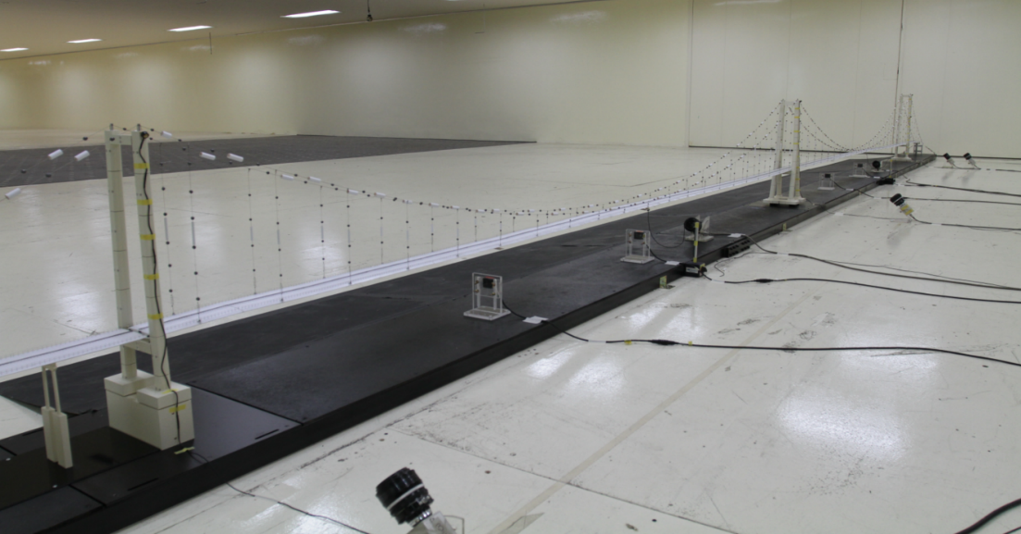

by
TESolution Co., Ltd.

July 24, 2022



TESolution Co., Ltd.
142 Seungjin-gil, Gongdo-eup,
Anseong-si, Gyeonggi-do, Korea
Tel: +82-31-658-2906~7
Fax: +82-31-658-2908
Homepage: www.tesolution.com

Dynamic Gust Response Analysis
for Chacao Bridge Catwalk

Proposal

July 24, 2020

We submit the proposal of Dynamic Gust Response Analysis for Catwalk System
of Chacao Bridge Project in Chile

SIGNATURE

S
-------------------------------------------------------------------------------------------------------------
SUBMITTED TO  Yunki SON, Vice President  T. 82-70-4811-4514 / F. +82-70-4811-4533  yunki@envico.biz  ENVICO Consultants Co., Ltd.  Republic of Korea |  | SUBMITTED BY  Seung Woo Lee, Managing Director  T. +82-31-658-2906 / F. +82-31-658-2908  swlee@tesolution.com  TESolution Co., Ltd  Republic of Korea

1. This proposal is valid for 90 days from the above date.
2. The information contained in this proposal is commercial in confidence and must not transmitted to a third party without the prior written agreement of TESolution.

TABLE OF CONTENTS

1. INTORUDUCTION 1
2. Scope of analysis 2
3. Methodology 3
4. Required Budget (VAT not included) 5
5. Schedule 6

INTORUDUCTION
This proposal provides an outline of dynamic gust response analysis to investigate aerodynamic performance of the catwalk system of Chacao Bridge in Chile.
Chacao Bridge consists of two adjacent cable-suspended main spans. The length of the Chacao Bridge will be 2,750m in total length, and consists of three concrete towers that are 157m and 199m high for the towers at each end and 175m high for tower in the middle. Two main spans are 1,055m and 1,155m each with suspended side spans of 216m and 324m steel box decks accommodating 4lane carriageway. Figure 1 shows general arrangement of the bridge.
Since the catwalk system is very flexible, large displacement due to wind loads is prone to occur. In order to evaluate the stability of the catwalk system due to wind load, it is necessary to conduct buffeting analysis, considering the geometric nonlinearity and the aerodynamic nonlinearity due to large displacement, to obtain precise static and dynamic displacement. Therefore, TESolution proposes a buffeting analysis that takes into account the geometric and aerodynamic nonlinearities.
There are two ways to evaluate the wind load coefficients of a catwalk: by conducting a wind tunnel test, and by applying the wind load coefficients of a catwalk similar to the catwalk used in this project.
In this project, we will apply the wind load coefficients of a similar catwalk, and if requested by the client, a wind tunnel test will be conducted to evaluate the wind load coefficients additionally.
This proposal for wind tunnel tests and buffeting analysis for the Canakkale Bridge Catwalk is prepared by TESolution, located at Anseong-si, Republic of Korea.

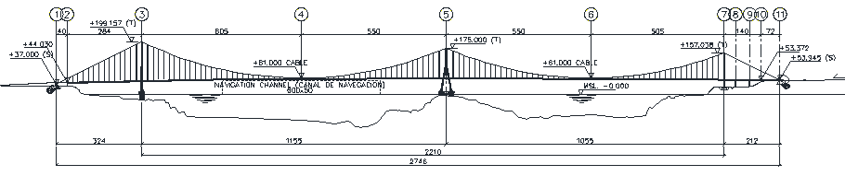
Figure 1.1 General arrangements

Purpose of analysis
The main purpose of buffeting analysis is as follows:

- To provide static displacement of catwalk at the design wind load and the working limit wind load
- To provide dynamic displacement of catwalk at the design wind load and the working limit wind load

Methodology

Nonlinear Aerostatic Displacement Analysis
The prediction of the wind-induced static displacement is based on the finite element method. The equation of static equilibrium in terms of a nodal displacement vector {Xs} for a structure system can be expressed in conventional matrix notation as follows:

([K_{S}]+[K_{G}]){X_{S}}={F_{S}}

where, [K_{S}] = structural stiffness matrix,
[K_{G}] = geometric stiffness matrix,
{F_{S}} = aerostatic force vector
all of which are expressed in global structure coordinate system.

For small displacement of catwalk, the change in {F_{S}} by displacement is negligible, and the above equation can be solved in the predeformation coordinate system. However, for large displacement of catwalk, which causes a variation in the angle of attack along the bridge axis, the change in {F_{S}} must be considered. Depending on the distortion of each element affected by wind load, the static aerodynamic force acting on each element should be progressively increased using a method that increases load on a step-by-step incremental basis. The geometric stiffness should be considered for each element so as to determine the incremental variations in displacements caused by changes in the aerodynamic static forces.

Dynamic Gust Response Analysis
Gust response is random vibration of a bridge caused by turbulence of an oncoming flow. Its vibration amplitude has a tendency to develop in almost proportion to a square of wind speed. Gust response is treated as a fluctuating wind loading problem in the wind-resistant design of long-span bridges.
The aerodynamic data and the calculated natural frequencies and mode shapes of the bridge based on the Eigenvalue analysis results will be used as input to gust response analysis.
The program used for dynamic gust response analysis has the following outstanding feature: The natural frequencies and mode shapes are obtained at each wind speed where gust response analysis is carried out. This means that natural frequencies and mode shapes take into account the geometric stiffness due to static wind loading acting on the bridge. Also, wind loading is calculated using static wind load coefficients for catwalk of the mathematical model after displacement due to static wind loading. For other research organizations, gust response analysis is usually conducted without taking into account the geometric stiffness and the change of aerodynamic static force coefficients due to displacement by static wind loading. Therefore, TESolution’s gust response analysis makes more precise wind engineering judgment against gust response of the catwalk possible.

Analysis Program
Nonlinear Aerostatic Displacement Analysis & Dynamic Gust Response Analysis
- Analysis items: static/dynamic displacement of catwalk, static divergence of catwalk
- Range of yaw angles: 0° (perpendicular to bridge span)
- Initial attack angle: 0° (horizontal)
- Wind Speed: design wind speed in construction stage (V_{d}), working limit wind speed in construction stage (V_{w})

Table 3.1 Test matrix for nonlinear aerostatic analysis & gust response analysis
No. | Structural State | Wind Speed | Structural Damping | Analysis Cases
1 | Catwalk system | 2 cases  (V_{d}, V_{w}) | 2 cases  (Design value, Load damping) | 4 cases

Required Budget (VAT not included)
Category | Budget | Note
(A) Gust wind response analysis
- Analysis Model construction
- Gust response analysis
TOTAL
Note:
▶Total Price above does not include performance bond or insurance.
▶Total Price above does not include any TAX.

Schedule

Please, note that the following project schedule provided below is for proposal purpose and is not final. The schedule is liable to change with various situations such as site status, component designs, and etc.
